**Raspberry Pi**

[**Raspberry Pi**](https://en.wikipedia.org/wiki/Raspberry_Pi) considered as one of the **cheapest computer** in the world. There are some reasons for this. It's a tiny little chip with a cute name Raspberry Pi. It can be used for coding and light using. You can build a pc with it. The cost will be under $150.

[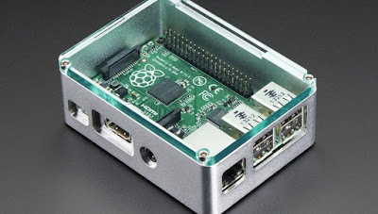](https://2.bp.blogspot.com/-6B1k46lo2qc/W7ZDzJ3ZcyI/AAAAAAAAAIU/Enia624JkDIq89cI9KemhSoPqukYpXUVACLcBGAs/s1600/pi2-970x675-970x550.jpg)

**What kind of use??**

Raspberry Pi considered as a best platform for coding. Because it has build in [Python](https://en.wikipedia.org/wiki/Python_(programming_language)). Learning Python in Raspberry Pi is best as my point of view. You can also run some light game in this computer. But the best thing about it is building various Raspberry Pi projects. You can search these projects in Google or Youtube. Our daily works in computer also can be done in Raspberry Pi. Like watching movie, sending mail, internet browsing, writing documents or blog etc.

[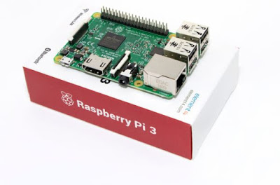](https://2.bp.blogspot.com/-cn9tzaPARIM/W7ZDV-eNZTI/AAAAAAAAAIE/76ZFRrfjwjkm5sX2P-Yd9i1XPUUNl4UowCLcBGAs/s1600/item_XL_10522094_13680816.jpg)

**Hardware**

Hardware in Raspberry Pi they are little bit smaller and less powerful. But it has everything like other computer. But there are some difference. It does't has any hard disk. External SD card perfoms the role of hard disk. As I said, it's just a chip so there will be no monitor and mouse. A power supply wire is also needed. Full "how to" explanation is given below.

[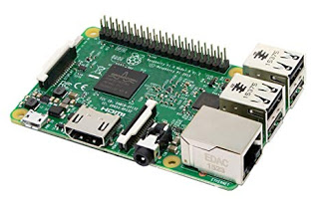](https://2.bp.blogspot.com/-M5HSo_jcQ9k/W7ZDe38XCJI/AAAAAAAAAII/JxjR6V4Mjd00r3YM0ChyGNsByJkQOacuwCLcBGAs/s1600/91zSu44%252B34L._SX466_.jpg)

**Building**

Building a Raspberry Pi computer is so much easy. First of all, you have to install os in your SD card. Remember SD card will play the role of hard disk so you have to install os in 32GB or 64GB  SD card. I suggest to buy 64GB for smooth performance. Then insert the SD card in Raspberry Pi. After that you have to connect the wire of power supply with it and also monitor with the Raspberry Pi. Then you can start Raspberry Pi. Remember Raspberry Pi can only run [Linux](https://en.wikipedia.org/wiki/Linux) but there are several distributions can be installed.

[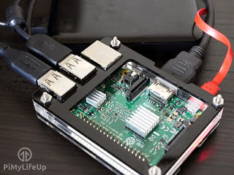](https://2.bp.blogspot.com/-NlvdLPGj32M/W7ZD3npTJBI/AAAAAAAAAIY/IN6kFUy2eDMyJ1c-K43U2-jpaF85F3JkACLcBGAs/s1600/Raspberry-Pi-Nextcloud-v3.jpg)

**Why will you buy it??**

Buying computer is some kind of costful for many peoples point of view. So it is affordable for everyone. Even if you are interested for hardcore coding so it's here for you. Or thinking about a pc which your children can use it lightly. There are some model of Raspberry Pi you can choose yours. The best thing about it that it also can be used as portable. So there are many reasons for buying a Raspberry Pi.